OOP Lab 10
Q1.
Source Code
class student:

@staticmethod
def input(self):
print("===Method input===")
name = input("Enter Student name: ")
roll = input("Enter Student roll no: ")
email = input("Enter Student email: ")
print("Student Name is: ", name)
print("Student roll is: ", roll)
print("Student email is: ", email)

@staticmethod
def course(self):
print("===Method course===")
classes = []
i = 0
j = input("Enter number of courses: ")
j = int(j)
while (i <= j-1):
className = input("Enter course name: ")
classes.append(className)
i = i +1
print(classes)

@staticmethod

def calculategpa(self):
print("===Method calculate gpa===")
k = input("Enter number of courses: ")
k = int(k)
for x in range(k):
grades = input("Enter grade of course: ")
print("Gpa of course is: ")
for element in grades:
if element == "A+":
print(4.0)
elif element == "A":
print(4.0)
elif element == "A-":
print(3.7)
elif element == "B+":
print(3.3)
elif element == "B":
print(3.3)
elif element == "B-":
print(2.7)
elif element == "C+":
print(2.3)
elif element == "C":
print(2.0)
elif element == "C-":
print(1.7)
elif element == "D":
print(1.0)

@staticmethod
def cgpa(self):
print("===Method calculate cgpa===")
cgpa = 0
c = input("Enter number of courses: ")
c = int (c)
for y in range(c):
gpa = input("Enter GPA of courses: ")
gpa = int(gpa)
cgpa = cgpa + gpa
cgpa = cgpa / c
print("The CGPA of Student is: ", cgpa)

nabeel = student()
nabeel.input(1)
nabeel.course(1)
nabeel.calculategpa(1)
nabeel.cgpa(1)

Output
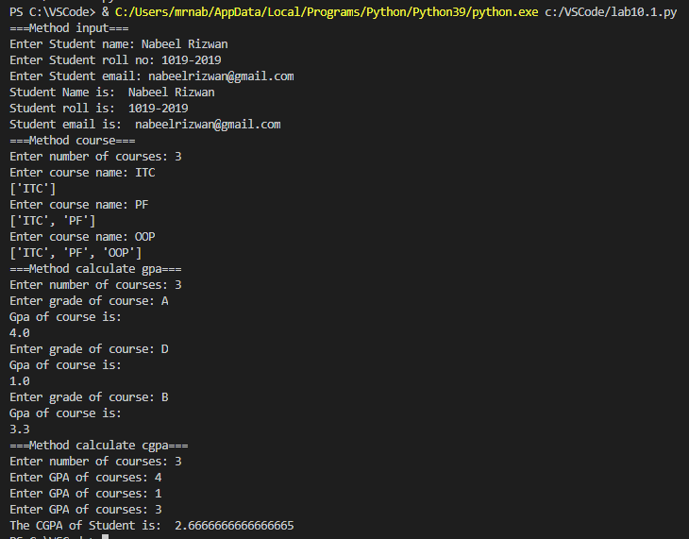

Q2.
Source Code
class Goat:

@staticmethod
def can_climb():
print("This is parent class")

class MountainGoat(Goat):

@staticmethod
def can_climb():
print("This is child class")

nabeel = Goat()
nabeel.can_climb()

nabeel = MountainGoat()
nabeel.can_climb()

Output

